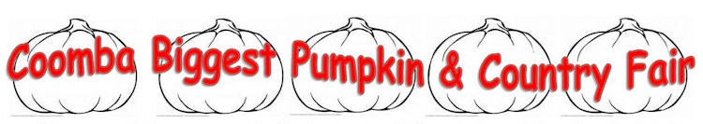
Easter Theme Amateur Cake Decorating Competition

RULES

- Cakes in this competition must have an Easter theme.
- Each exhibit must be the handmade work of the individual contestant.
- The inside of the cake itself may be any normal, edible variety.
- Cake may be any shape and number of layers but not tiered using pillars (as in wedding cakes).
- Cake and board must not exceed 30cm in any direction including overall decorated height.
- Cakes to be decorated with approximately 90% edible materials.
- All icing to be made by the contestant with the exception of fondant.
- No manufactured ornaments permitted. Edible food colours, lustres, glitter etc along with small amounts of ribbons, braids etc., may be used.
- Contestants should be prepared for the varied temperatures and humidity which can affect the behaviour of frostings. No refrigeration is provided.
- Cakes will be displayed under cover

JUNIORS ONLY : May exhibit up to 6 cupcakes instead.

………………………………………………………………………………………………………………………………………………………………………
CAKE DECORATING COMPETITION ENTRY FORM

Name of Entrant …………………………………………………………………………………………………………………….

Age Group – adult / child under 12 (please circle)
Email address …………………………………………………………………………………………………………………………..

Phone number …………………………………………………………………………………………………………………………..

- NOTE: All cakes become the property of the Coomba Biggest Pumpkin and Country Fair, and will be sold to help raise funds for the Coomba Tidal Pool
- I agree to accept the conditions of entry and that the judges’ decision is final
Signature of entrant or carer for a child entrant

…………………………………………………………………………………………………………………………………………………………..………
EASTER THEME AMATEUR CAKE DECORATING JUDGING CRITERIA

Note: Cakes will not be cut or judged on taste.

IMPORTANT NOTES  - 2 Classes – Adults and Junior – age 12 or under  - Open to Novices only – amateurs who have not previously won major prizes  - Entries to be received not less than 2 days prior  (i.e. 18th April) by:-  (phone or email if necessary 65542001 or 0417 427 572, deljeal@nepenblue.com.au) giving your contact information  - Entry forms can be dropped into the letterbox of 47 Coomba Rd), emailed, or taken to the event, as along as a verbal / email/ text received by 18th April  - Entry is a Gold coin donation on the day  - Cakes to arrive at the Coomba Foreshore Park before 9.30am for judging. Late entries will not be judged.  - Further info Del Jeal – 65542001 or 0417 427 572 or deljeal@nepeanblue.com.au | JUDGING CRITERIA
 | - Creativity & originality | 25
 | - Reference to Easter theme | 15
 | - Use of colour and frosting | 20
 | - Technique & application | 15
 | e) Overall display – visual impact | 25
___
100
The decision of all judging is final.
The Coomba Biggest Pumpkin &Country Fair reserves the final judgement on all matters pertaining to the contest.
WAIVER: Late entries and exhibits not complying with the rules may not be judged but may be displayed.

.

NOTE: Names of winners will be given to local press and used in some media outlets. If you do not wish your name to be used circle ………………………. YES / NO

NOTE 2. No information appertaining to any entrants will be given to or shared with any individual or organisation.

