NEW MEMBERS - PLEASE COMPLETE BOTH SIDES OF THIS FORM

Coomba Connections subscriptions and Progress Association membership

1 July 2017 – 30 June 2018

Membership Options
Please mark to indicate your choice
For those wanting a PRINT COPY of Coomba Connections: |  |  | Your selection
Single Membership with Coomba Connections Print Copy,  delivered in local area. |  | $20.00
Single Membership with Coomba Connections Print Copy,  posted outside local area. |  | $32.00
Family Membership with Coomba Connections Print Copy,  delivered in local area. |  | $24.00
Family Membership with Coomba Connections Print Copy,  posted outside local area. |  | $36.00
For those wanting EMAIL ONLY COPY of Coomba Connections:
Single Membership with Coomba Connections Email Copy | $10.00
Family Membership with Coomba Connections Email Copy | $14.00

If you chose to receive a printed copy to be posted outside local area, an
ADDITIONAL $12 has been included in above prices to cover postage costs.
(Local delivery area is the area from the Coomba Rd. & Lakesway intersection to Coomba Village.)

AMOUNT PAID: ………$..........................

PLEASE RETURN THIS FORM WITH PAYMENT TO:
Treasurer, Beverly Fitzpatrick – 18 The Lakelands Coomba Park 02 6554 2146 coombaprogress@gmail.com or
OR for Direct Bank Deposit, pay
Westpac Bank,
Account Name: Coomba & District Progress Association Inc.
BSB: 032 543
Account No: 113606
Reference: Please put your SURNAME in the Bank reference
Please deliver or email the completed form to the address above or
to the Secretary, Sarah-Jane Huntley 11 Kamarooka St Coomba Park 2428
sj_huntley@yahoo.com.au
Name: ………………………………………………………………………………………………………………………………………….
Phone Number: ……………………………………………………………………………………………………………………………

Email address: ………………………………………………………………………………………………………………………………
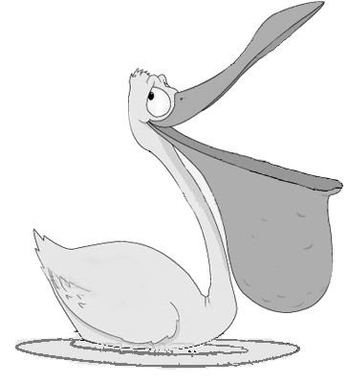
COOMBA & DISTRICT PROGRESS ASSOCIATION INC.
(established 1974)

President: David Gemmel 1601 Coomba Rd Coomba Bay 2428 6554 2269
Vice Pres: Barbara Filter 6 Dandenong Cresc Coomba Park 2428 6554 2312
Secretary: Sarah-Jane Huntley 11 Kamarooka St Coomba Park 2428 6554 2315
Treasurer: Beverly Fitzpatrick 18 The Lakelands Coomba Park 2428 65542146

Dear Members

In 2014 Coomba & District Progress Association Inc. amended its Constitution to bring it in line with the requirements of NSW Fair Trading. This form asks for the details that are required on an application for Membership.

Applicants for new Memberships or for re-activation of a previous membership that has not been renewed in the past 12 months are asked to complete pages 1 and 2 of this form.

Members who are making an ongoing renewal need only fill in the other page of this form.

Please complete the form and submit it with payment to the Treasurer or Secretary.

Thanks,

Sarah-Jane Huntley, Secretary

Application for membership

COOMBA & DISTRICT PROGRESS ASSOCIATION
(Incorporated under the Associations Incorporation Act 2009)

I/we, …………………………………………………………………………………………………………………………….
[full name of applicant]

of ………………………………………………………………………………………………………………………………….
[home address]

………………………………………………………………………………………………………………………………………
[occupation]
hereby apply to become a member/s / re-activate a lapsed membership
(cross out which does not apply)
of the above named incorporated association. As a member, I agree to be bound by the constitution of the association for the time being in force.

……………………………………………………………………………………………………………………………………
(Property address in Coomba area if different from home address)

……………………………………………………………………………………………………………………………………..
(e-mail address)

Home Phone: ………………….................. Mob Phone:……………………………………………………………………..

Date: …………………………………Signature of applicant: ………………………………………………………………………

Please return this form to the
Association Treasurer, 18 The Lakelands Coomba Park - coombaprogress@gmail.com OR
Association Secretary, 11 Kamarooka St Coomba Park - sj_huntley@yahoo.com.au
together with the appropriate fee, which also covers your Coomba Connections subscription.
The schedule of fees is shown on page 1, with bank details for electronic banking.

