GIANT PUMPKIN &
Unusually shaped veg/fruit &
carved, decorated or dressed pumpkin
COMPETITIONS
at Coomba Country Fair
Coomba Park foreshore 9.00am to 1.00pm
Easter Saturday 11thApril 2020
judging around noon.
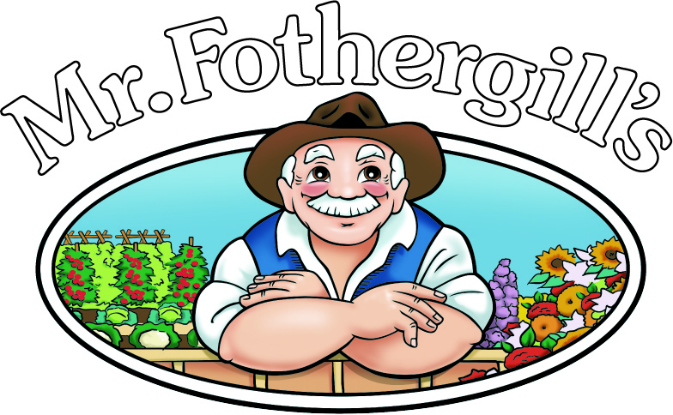
SPONSORED BY FOTHERGILL’s SEEDS
GREAT PRIZES
All Entry forms available
from this site -
Get your seeds from
- Coomba General Store
- The Brunch Café on Sunday mornings
- Tourism shop in Blueys
- By phoning Del 0417427572 or Barb 0490 190 271
Pumpkins seeds -  Big Max seeds from 2019 winner, and  Giant Atlantic seeds  which are the world’s biggest pumpkins  available with the Competition entry form  Just $10 | ODD BODS vegies –  & decorated, dressed, carved pumpkins –  use your own plants/seeds. Competition Entry Form  Just $10
Entries from Adults, Children, School Groups welcome
(The sooner you plant the bigger they will grow!)
This event is a fund raiser for Coomba Tidal Pool and Coomba environs

